**MERGE**

MERGE INTO STAFF_EMP se

USING EMPLYS e

ON (se.STAFF_NAME= e.STAFF_NAME)

WHEN MATCHED THEN UPDATE

SET

se.DEPT = e.DEPT,

se.DEPT_ID = e.DEPT_ID

WHEN NOT MATCHED THEN INSERT

VALUES (e.STAFF_NAME, e.DEPT, e.DEPT_ID);

SELECT * FROM STAFF_EMP

**OUTPUT:-**

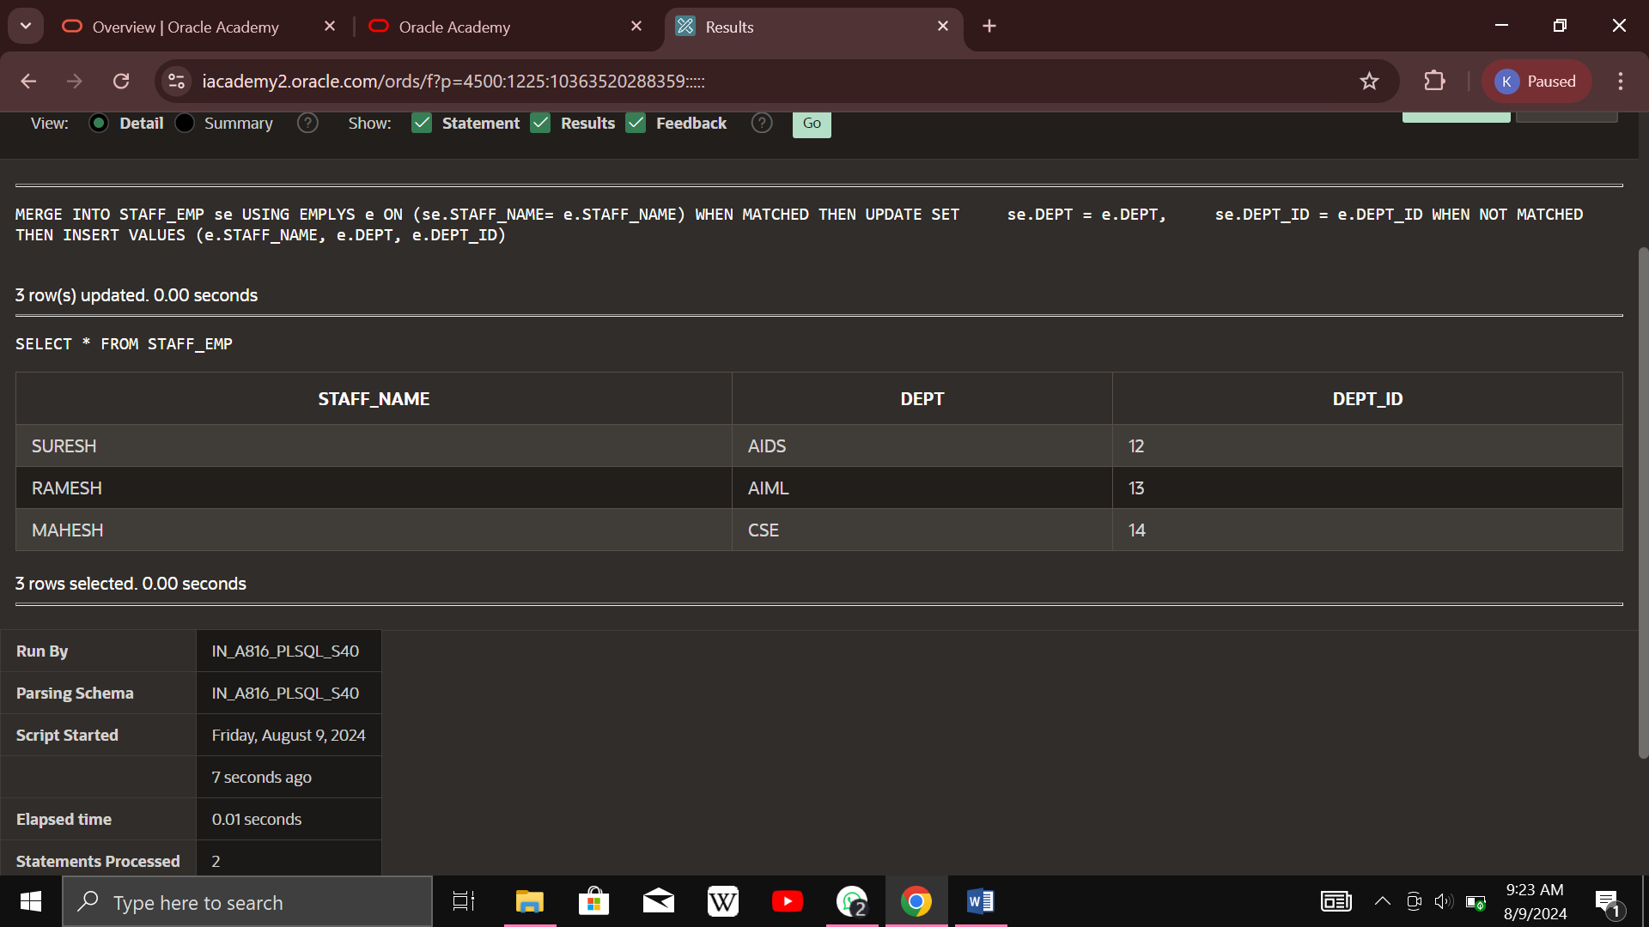

**SEQUENCE**

CREATE SEQUENCE sequence_9

INCREMENT BY 1

START WITH 1

MAXVALUE 50000

NOCACHE

NOCYCLE;

SELECT staff, dept, salary, age,

dept_id

FROM saveetha;

CREATE TABLE student_9

(

salary number(10),

staff varchar(20)

);

INSERT into student_9 VALUES

(sequence_9.nextval,'Shubham');

INSERT into student_9 VALUES

(sequence_9.nextval,'Aman');

**OUTPUT:-**

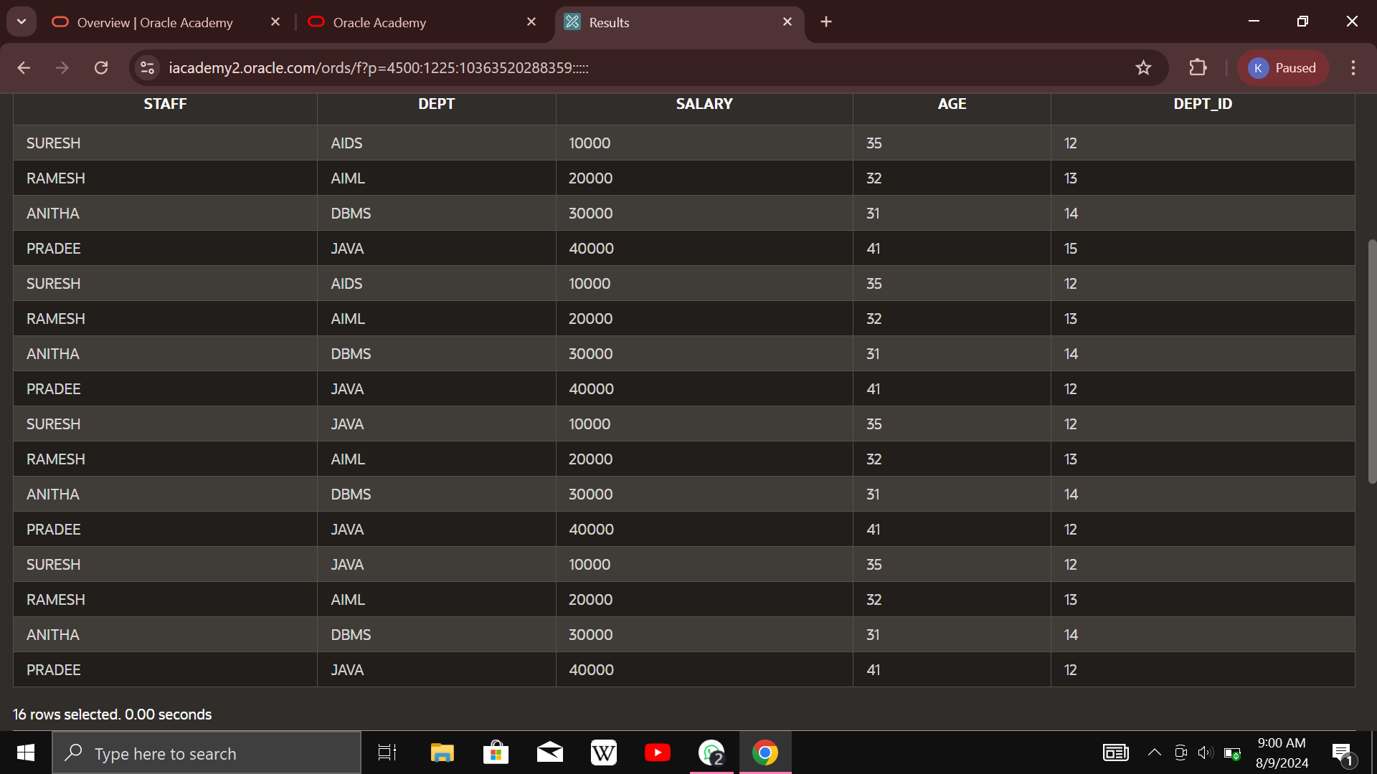

**OUTPUT STATEMENT:**

BEGIN

DBMS_OUTPUT.PUT_LINE('PL/SQL is easy!');

END;

**OUTPUT:**

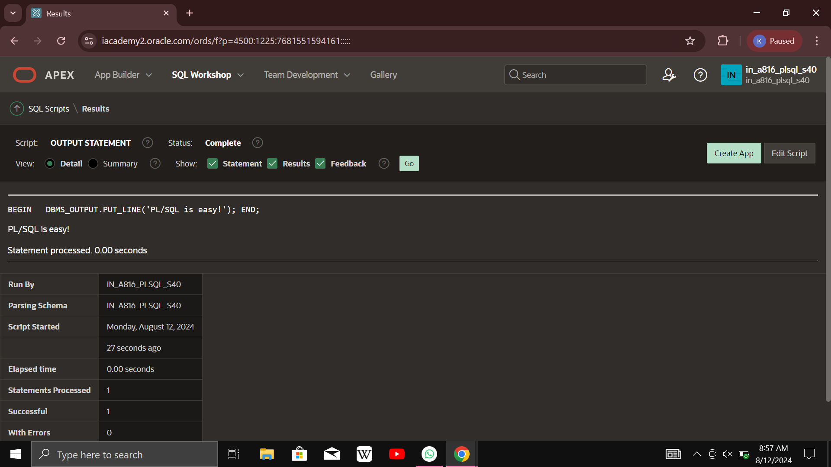

**Declarative And Executable:**

DECLARE

v_date DATE := SYSDATE;

BEGIN

DBMS_OUTPUT.PUT_LINE(v_date);

END;

**Output:-**

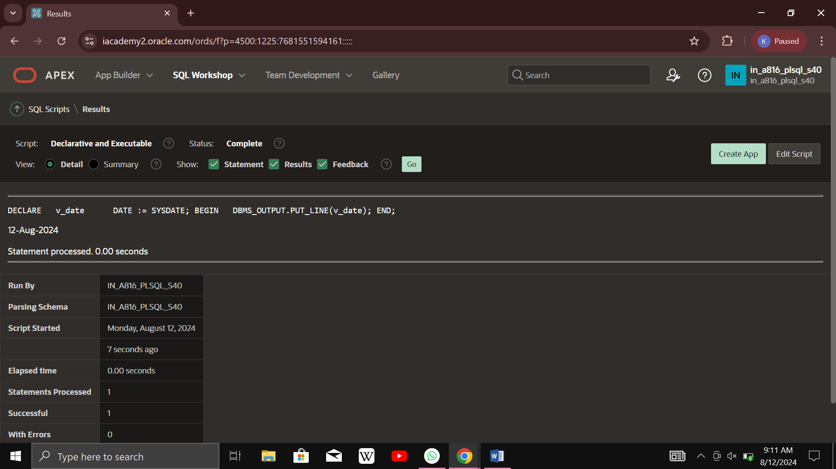

**Declarative,Executable and Exception:**

DECLARE

v_first_name VARCHAR2(10);

v_last_name VARCHAR2(15);

BEGIN

SELECT first_name, last_name

INTO v_first_name, v_last_name

FROM employees1

WHERE last_name = 'SURESH';

DBMS_OUTPUT.PUT_LINE('The employee of the month is:'

|| v_first_name || ' ' || v_last_name || '.');

EXCEPTION

WHEN TOO_MANY_ROWS THEN

DBMS_OUTPUT.PUT_LINE('Your select statement retrieved multiple rows.

consider using a cursor or changing the search criteria.');

END;

**Output:**

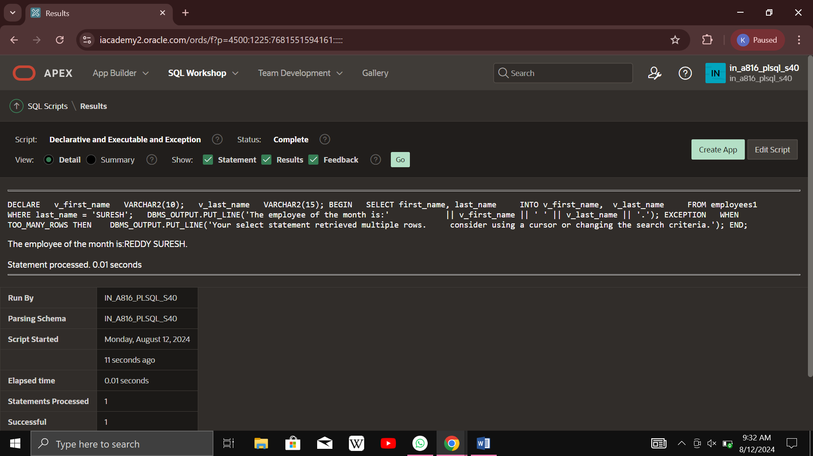

**Count the No of Words nd Characters:**

DECLARE

str VARCHAR2(40) := 'Tutorials Point';

nchars NUMBER(4) := 0;

nwords NUMBER(4) := 1;

s CHAR;

BEGIN

FOR i IN 1..Length(str) LOOP

s := Substr(str, i, 1);

nchars:= nchars+ 1;

IF s = ' ' THEN

nwords := nwords + 1;

END IF;

END LOOP;

dbms_output.Put_line('count of characters is:'

||nchars);

dbms_output.Put_line('Count of words are: '

||nwords);

END;

**Output:**

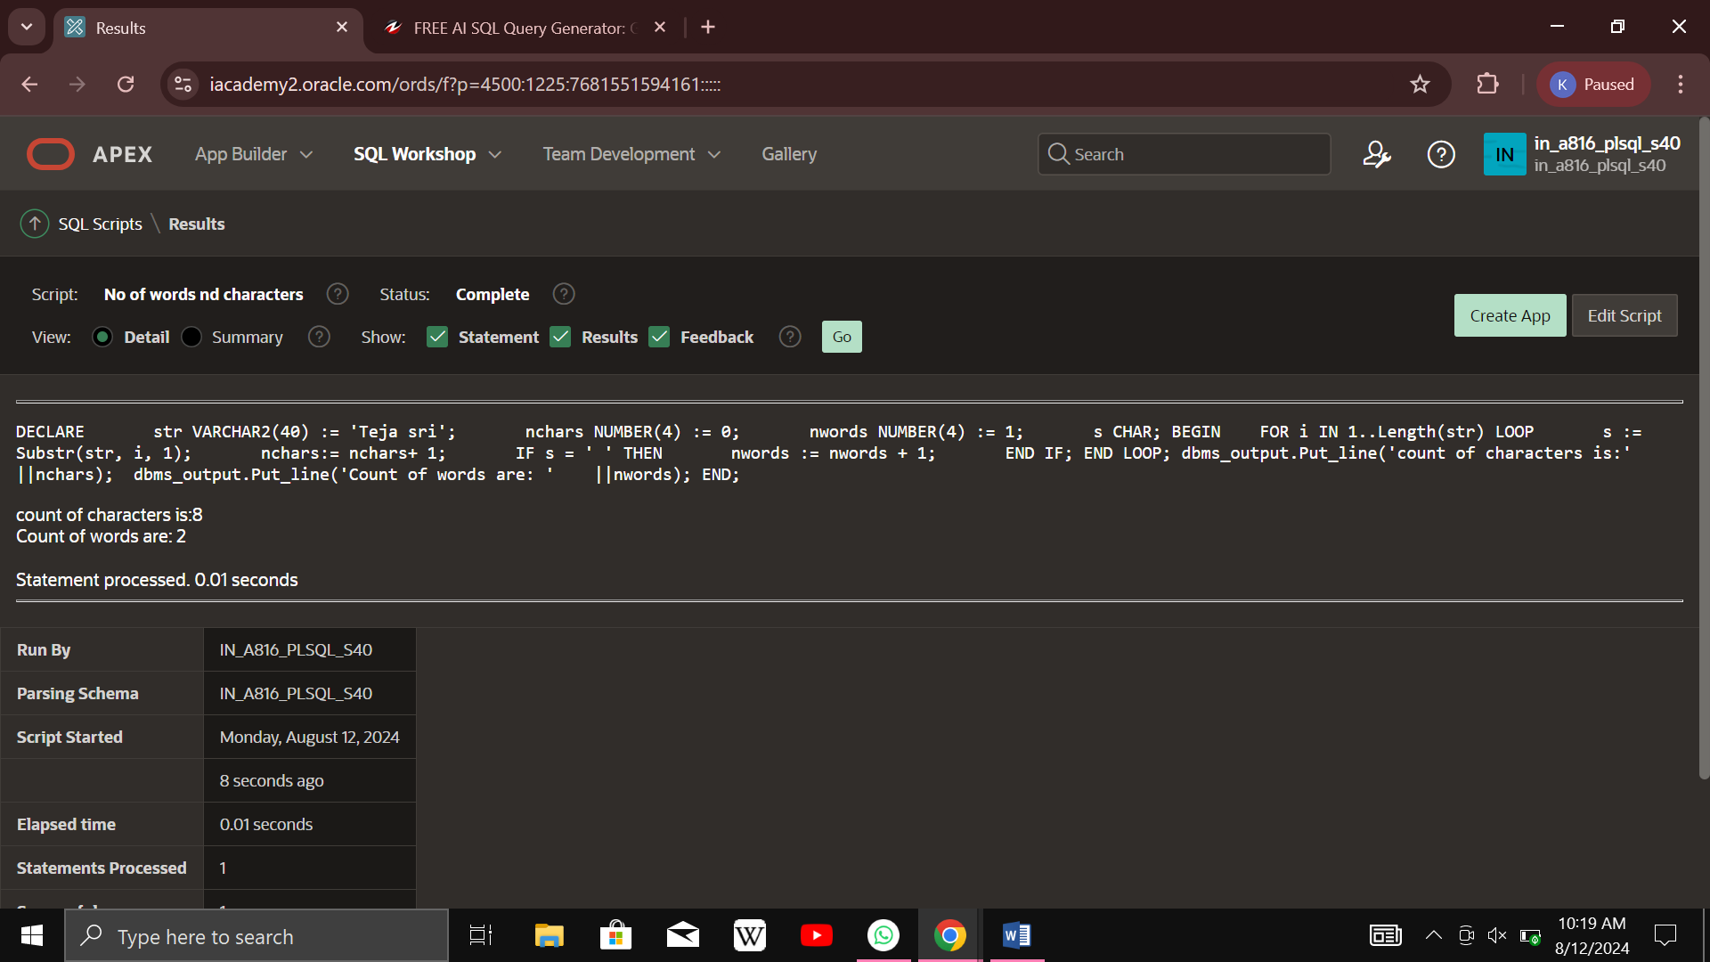

**Add two numbers:**

DECLARE

a integer := 10;

b integer := 20;

c integer;

f real;

BEGIN

c := a + b;

dbms_output.put_line('Value of c: ' || c);

f := 70.0/3.0;

dbms_output.put_line('Value of f: ' || f);

END;

**Output:**

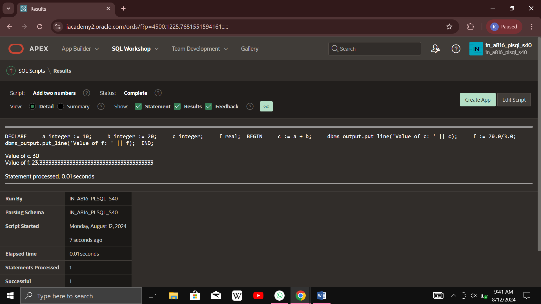

**Radius, Diameter, Circumference, Area:**

DECLARE

-- constant declaration

pi constant number := 3.141592654;

-- other declarations

radius number(5,2);

dia number(5,2);

circumference number(7, 2);

area number (10, 2);

BEGIN

-- processing

radius := 9.5;

dia := radius * 2;

circumference := 2.0 * pi * radius;

area := pi * radius * radius;

-- output

dbms_output.put_line('Radius: ' || radius);

dbms_output.put_line('Diameter: ' || dia);

dbms_output.put_line('Circumference: ' || circumference);

dbms_output.put_line('Area: ' || area);

END;

**Output:**

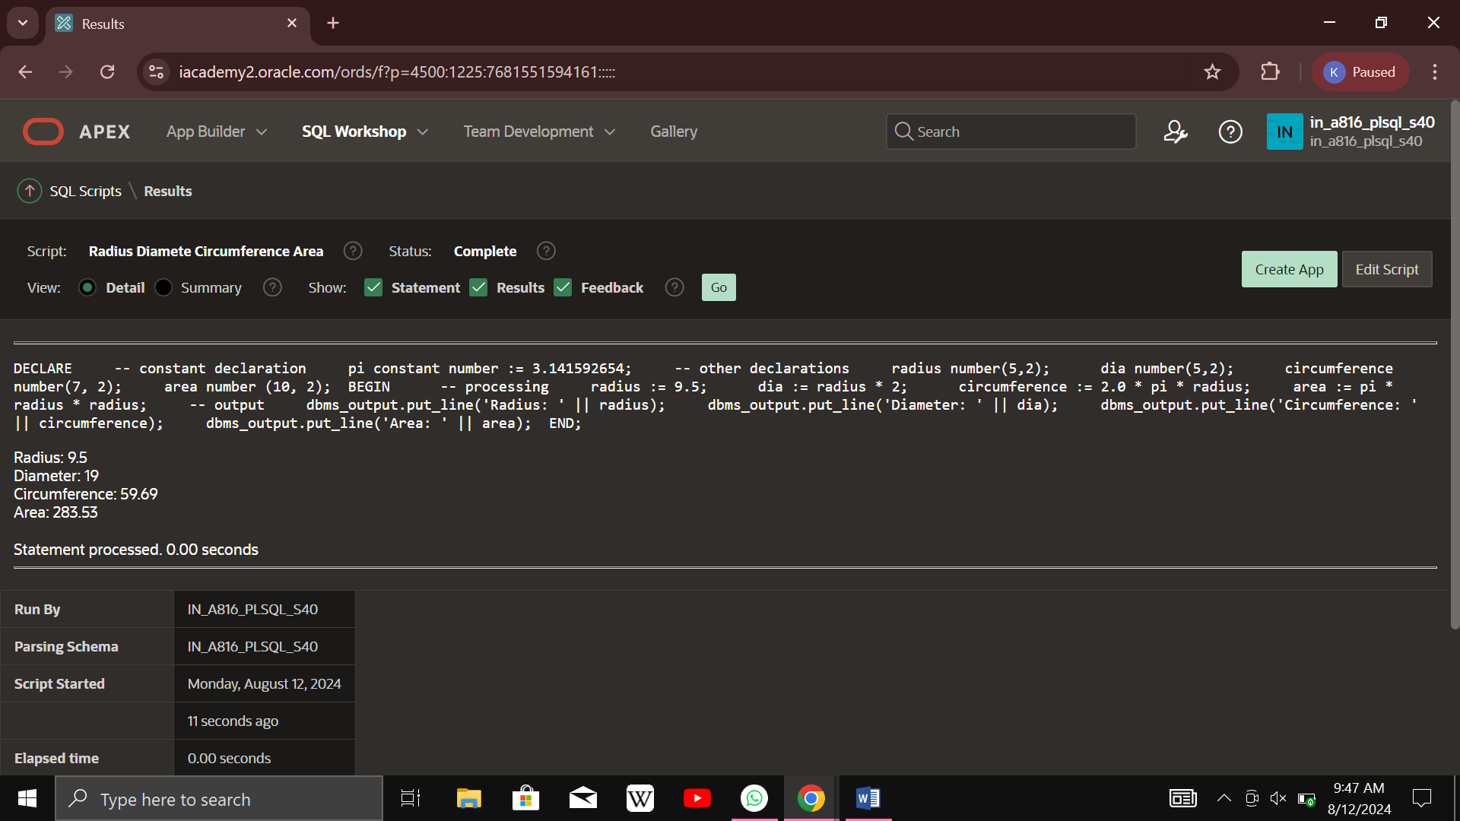

**Sum of n Numbers:**

DECLARE

sumVal NUMBER;

n NUMBER;

i NUMBER;

FUNCTION Findmax(n IN NUMBER)

RETURN NUMBER

IS

sums NUMBER := 0;

BEGIN

FOR i IN 1..n

LOOP

sums := sums + i*(i+1)/2;

END LOOP;

RETURN sums;

END;

BEGIN

n := 8;

sumVal := findmax(n);

dbms_output.Put_line('Sum of natural numbers is ' || sumVal);

END;

**Output:**

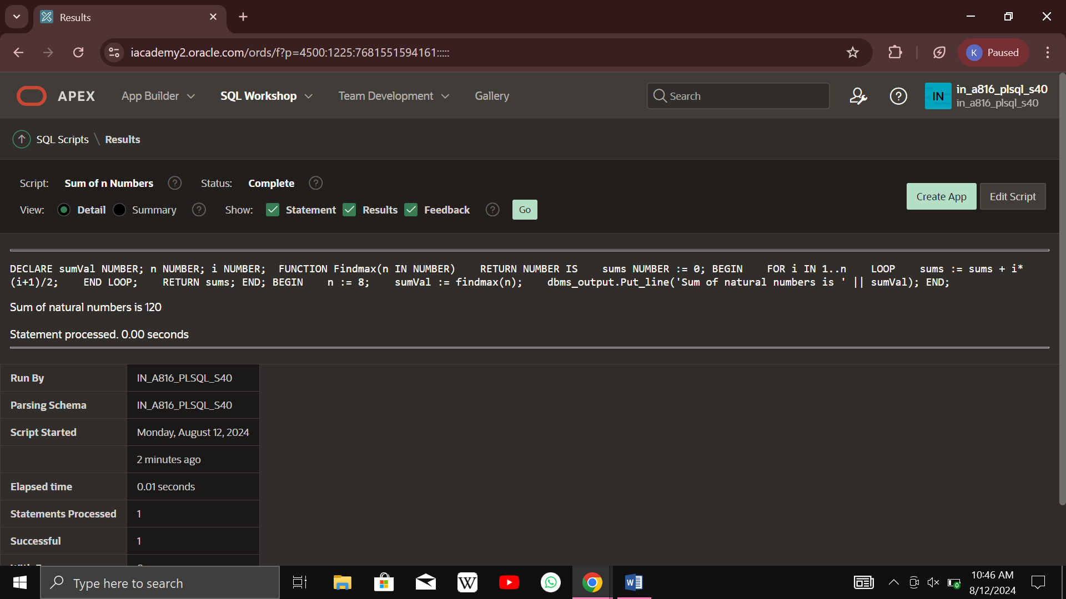

**ARRAY:**

DECLARE

type namesarray IS VARRAY(6) OF VARCHAR2(10);

type grades IS VARRAY(6) OF INTEGER;

names namesarray;

marks grades;

total integer;

BEGIN

names := namesarray('Ardhya','Jishnu','Ayan','Neil','Stalin','Tara');

marks:= grades(98, 97, 78, 87, 58, 69);

total := names.count;

dbms_output.put_line('Total '|| total || ' Students');

FOR i in 1 .. total LOOP

dbms_output.put_line('Student: ' || names(i) || '

Marks: ' || marks(i));

END LOOP;

END;

**OUTPUT:**

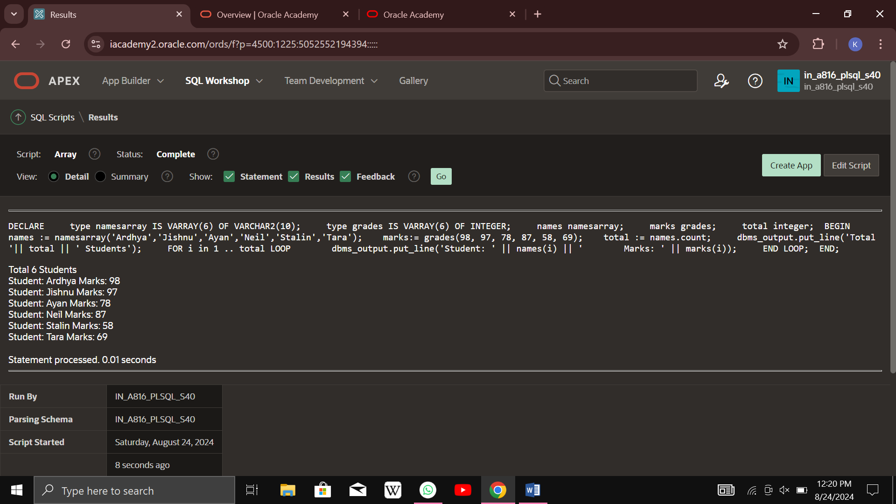

**PROCEDURE FIND MIN:**

DECLARE

a number;

b number;

c number;

PROCEDURE findMin(x IN number, y IN number, z OUT number) IS

BEGIN

IF x < y THEN

z:= x;

ELSE

z:= y;

END IF;

END;

BEGIN

a:= 23;

b:= 45;

findMin(a, b, c);

dbms_output.put_line(' Minimum of (23, 45) : ' || c);

END;

**OUTPUT:**

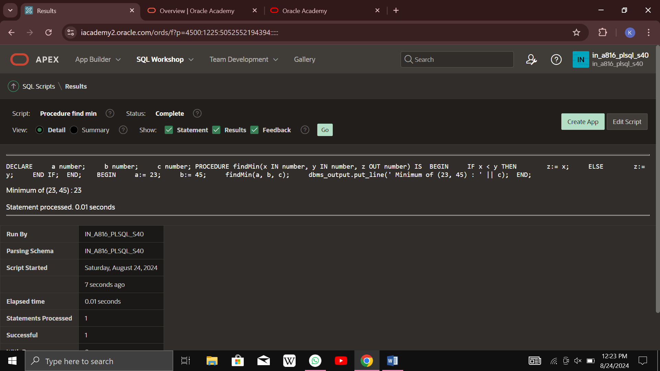

**Create Procedure PRINT_DATE:**

CREATE OR REPLACE PROCEDURE print_date IS

v_date VARCHAR2(30);

BEGIN

SELECT TO_CHAR(SYSDATE,'08 13, 2024')

INTO v_date

FROM DUAL;

DBMS_OUTPUT.PUT_LINE(v_date);

END;

**OUTPUT:**

